**BLACK FRIDAY ANALYSIS – SAS PROJECT REPORT**

**ERIC YE**

**AR KAR MIN**

**March 26th, 2021**

**BUSINESS DATA (INTRODUCTION):**

A retail company, “ABC Private Limited” wants to understand their customer purchase behavior against products of different categories. They have collected data over the span of the previous month. They want to analyze purchase amount behavior for customers based on the variables given. Their goal is to learn from past sales in order to improve and increase future sales. The dataset contains 550069 observations, 12 variables (7 numeric, and 5 character)

**BUSINESS QUESTIONS:**

**Analysis questions:**

1. What effects do the masked variable have on the Purchase amount? Can we predict Purchase amount with the masked variables? (Occupation and Product categories)
2. What product categories influence the purchase amount the most? Or none?
3. What gender and age groups like to purchase more on Black Friday?
4. What variables are strongest in influencing purchasing amount?
5. Is it possible for us to narrow most purchases to a certain group of people? Such as women which are not married, men in a certain age range, etc…

**STUDY FRAMEWORK**

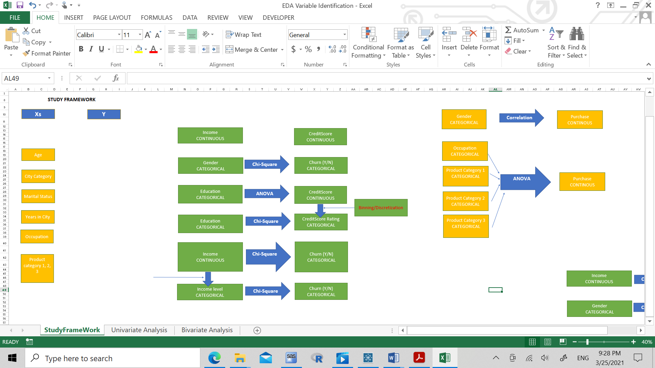

**Check missing values:**

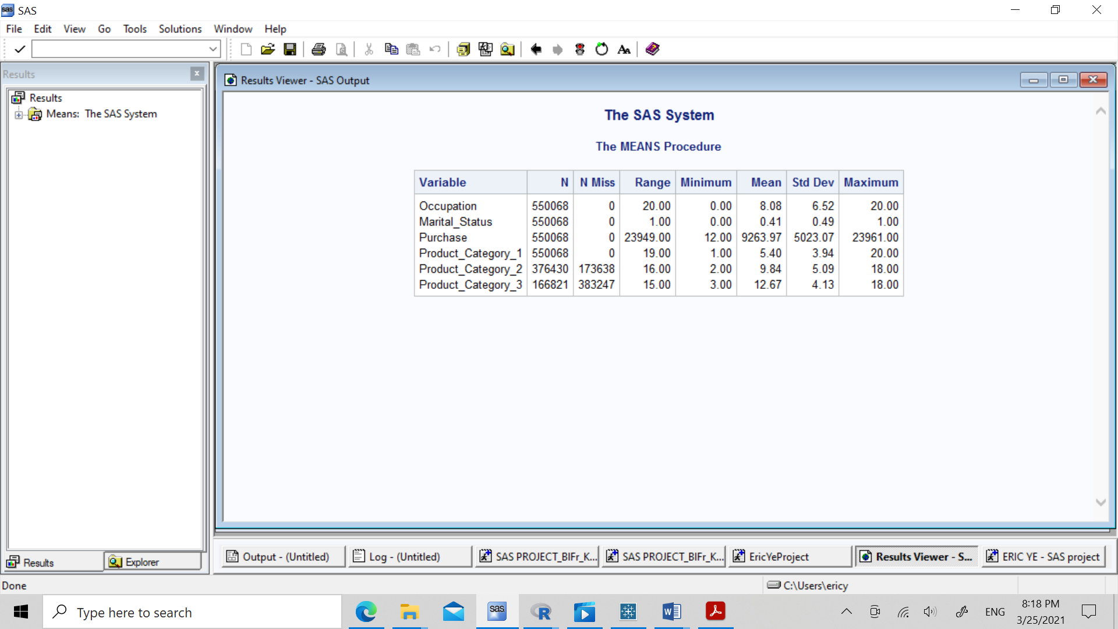

Since there are missing values within the Product_Category_2 and Product_Category_3, we choose to replace these with 0.

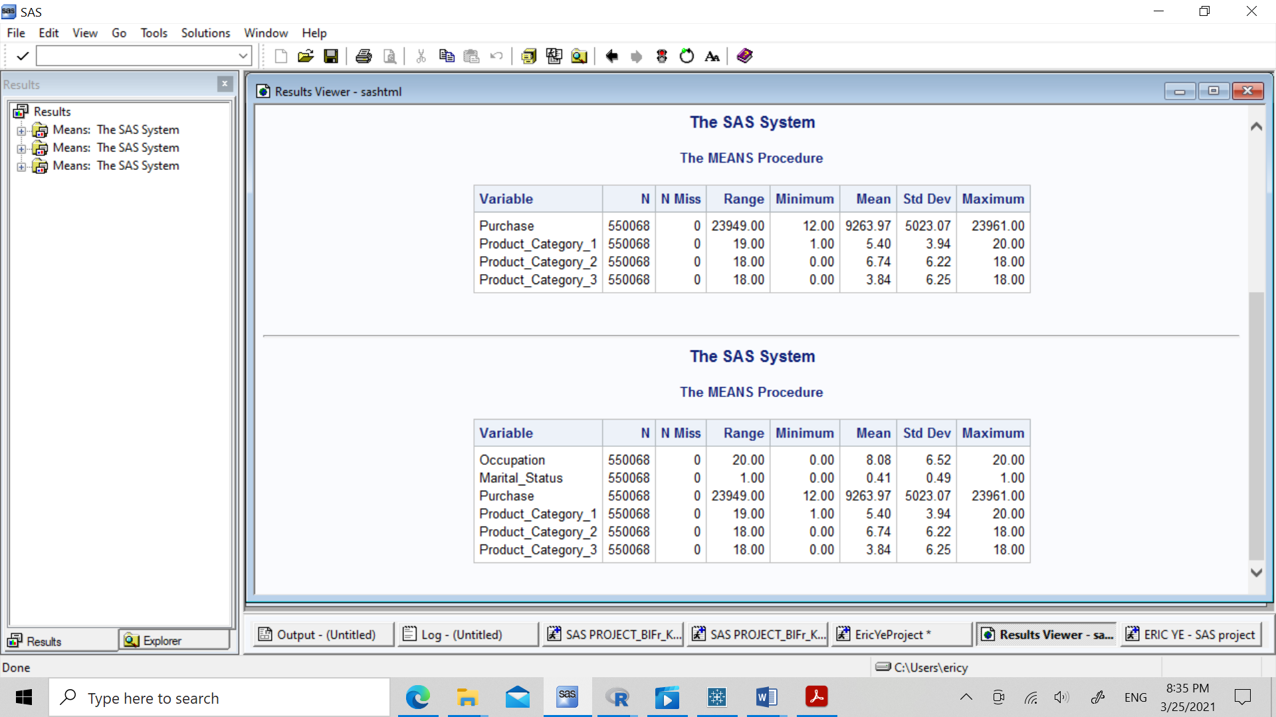

**UNIVARIATE ANALYSIS:**

**Categorical Variable (Frequencies):**

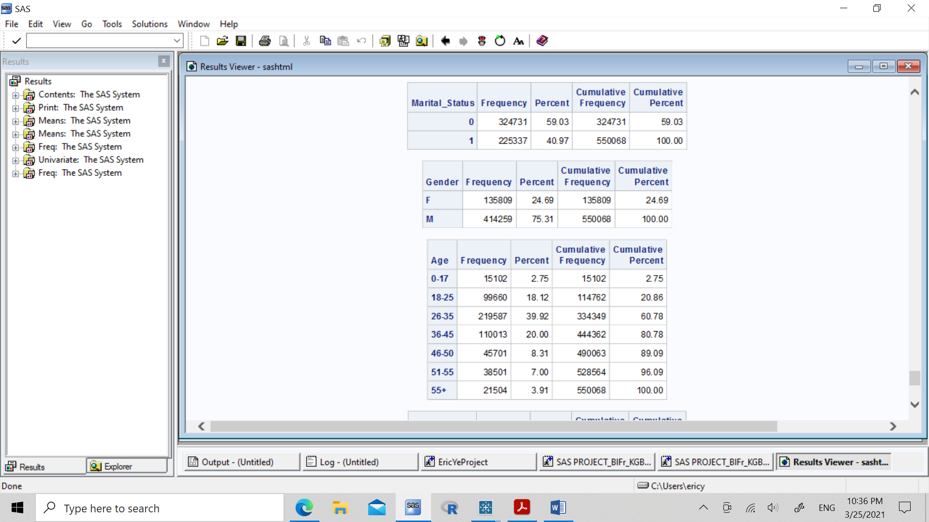 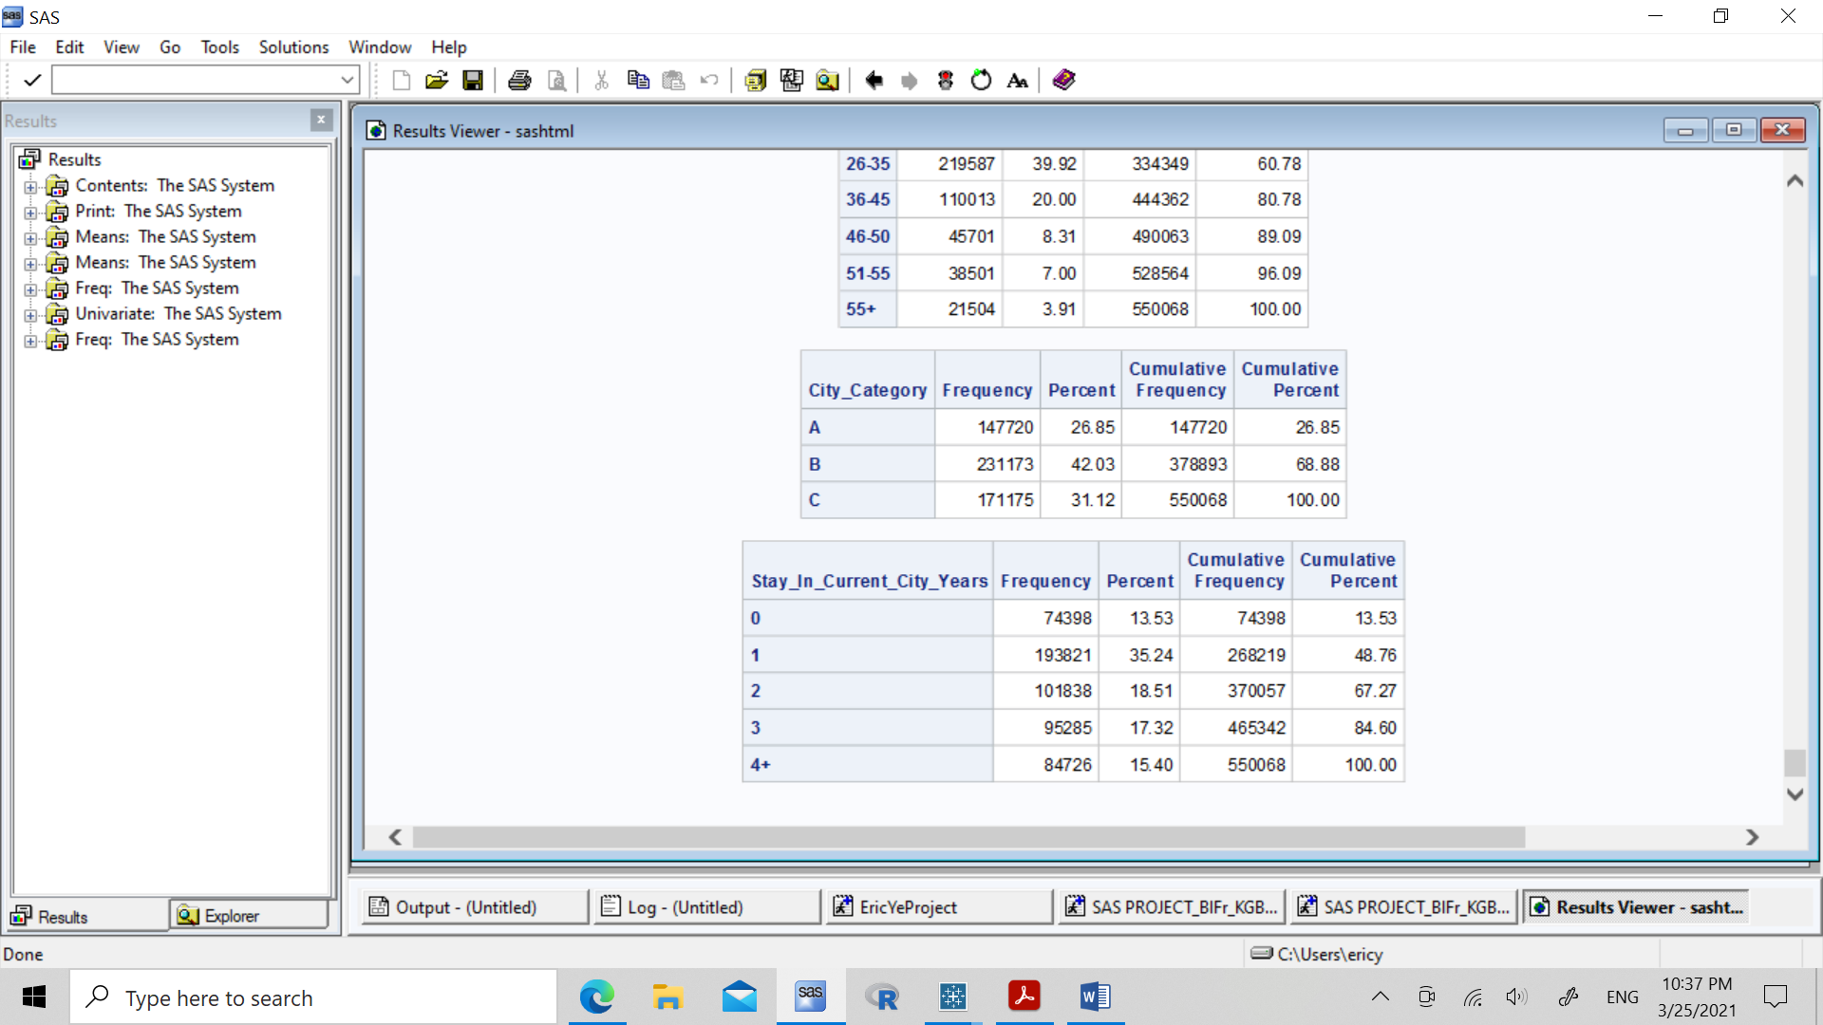

**Continuous Variables (5 number summary):**

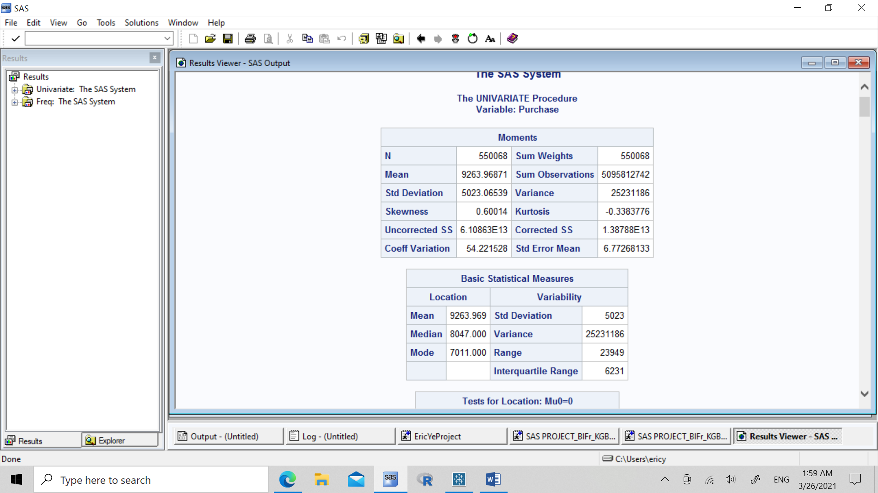

**OUTLIER REMOVAL:**

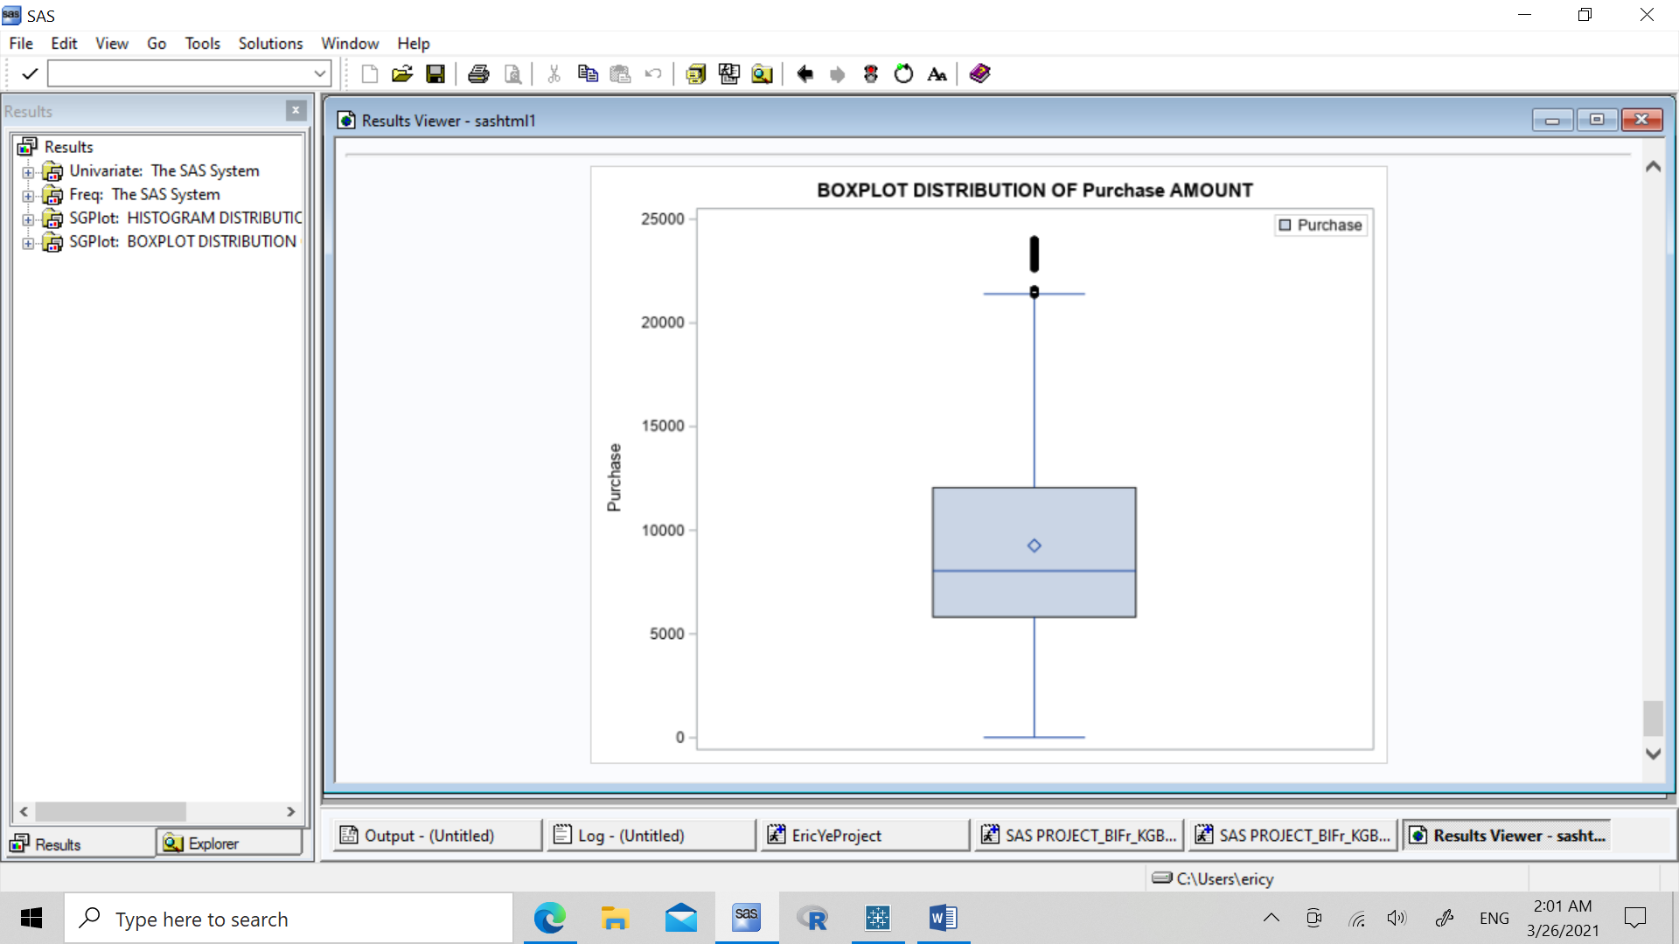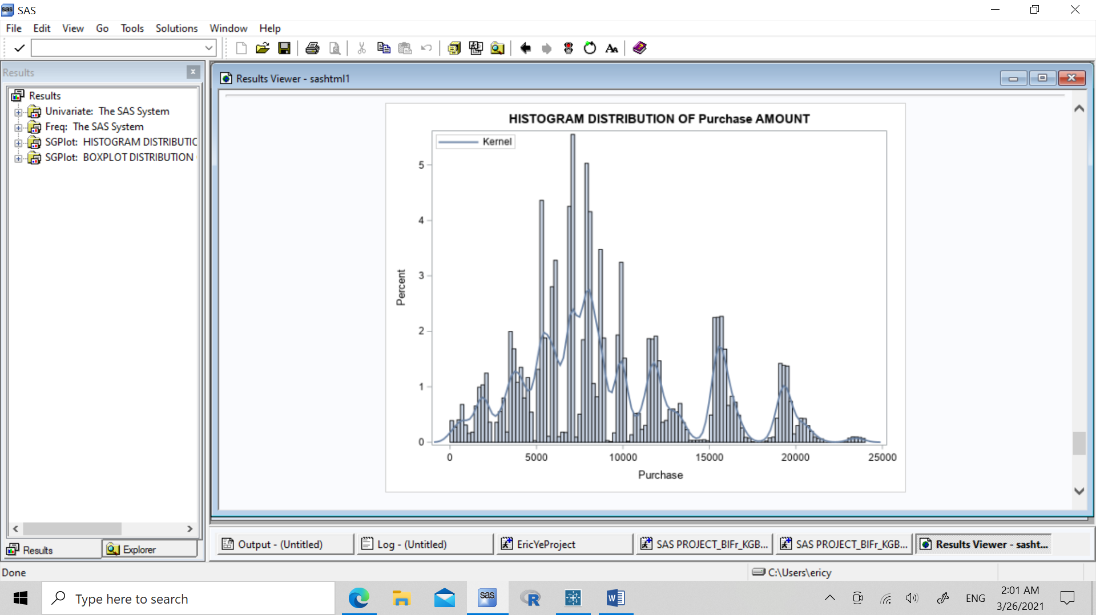

From the histogram and box plot, we can see the positive skewness in the distribution, so we remove the outliers to achieve normality assumption in Purchase target variable

**Result:**

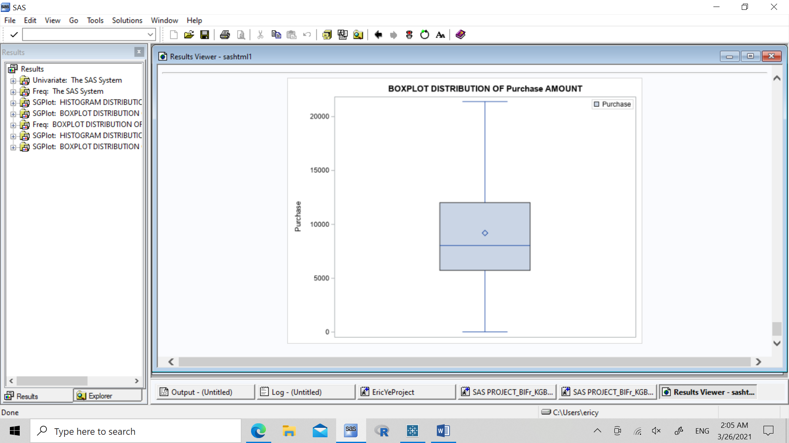 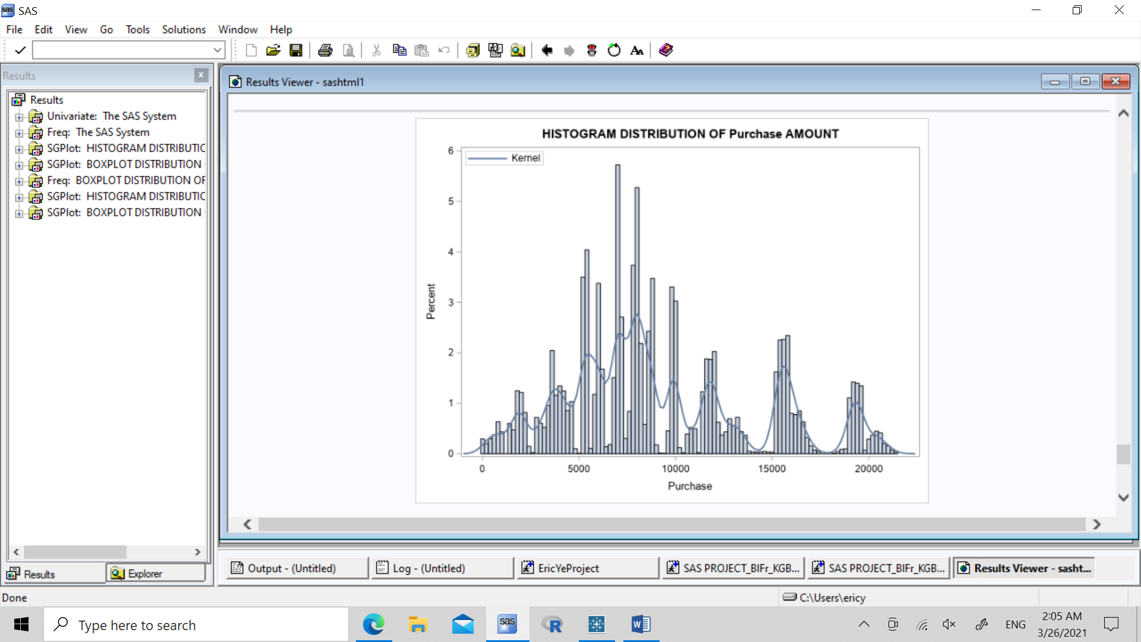

**GRAPHICS (CATEGORICAL VARIABLES):**

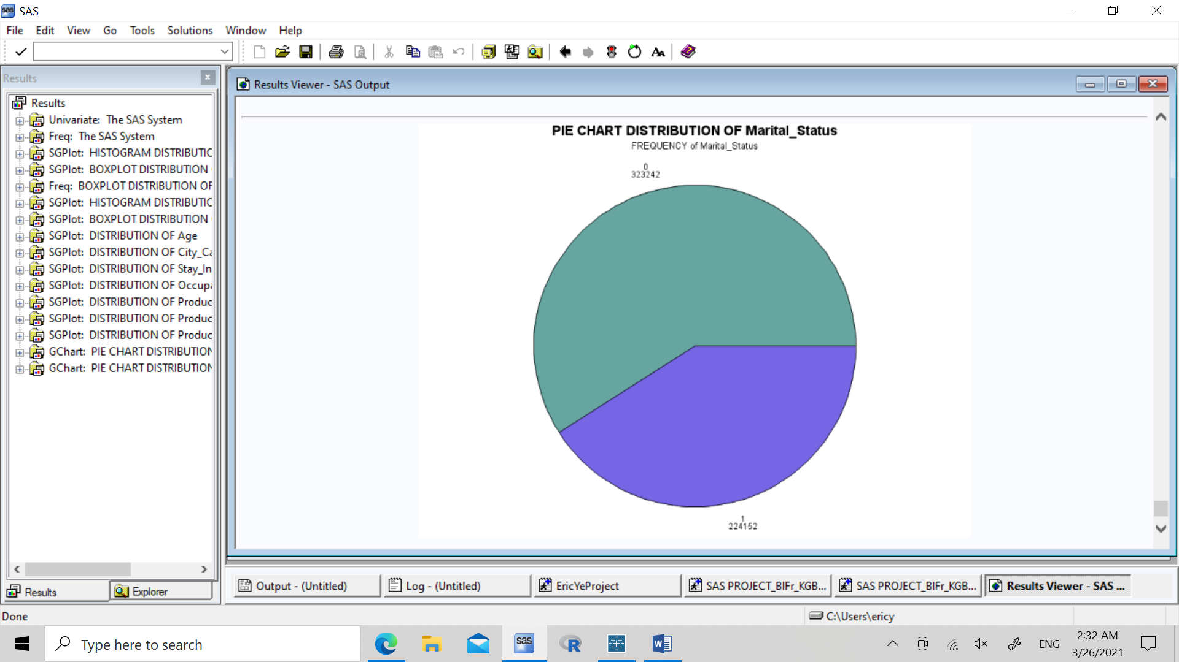 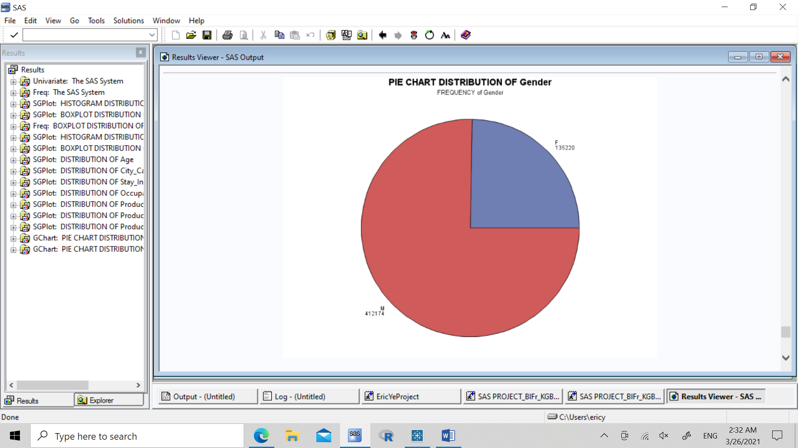

We see here that around 60% of shoppers are not married, and around 75% of shoppers are males.

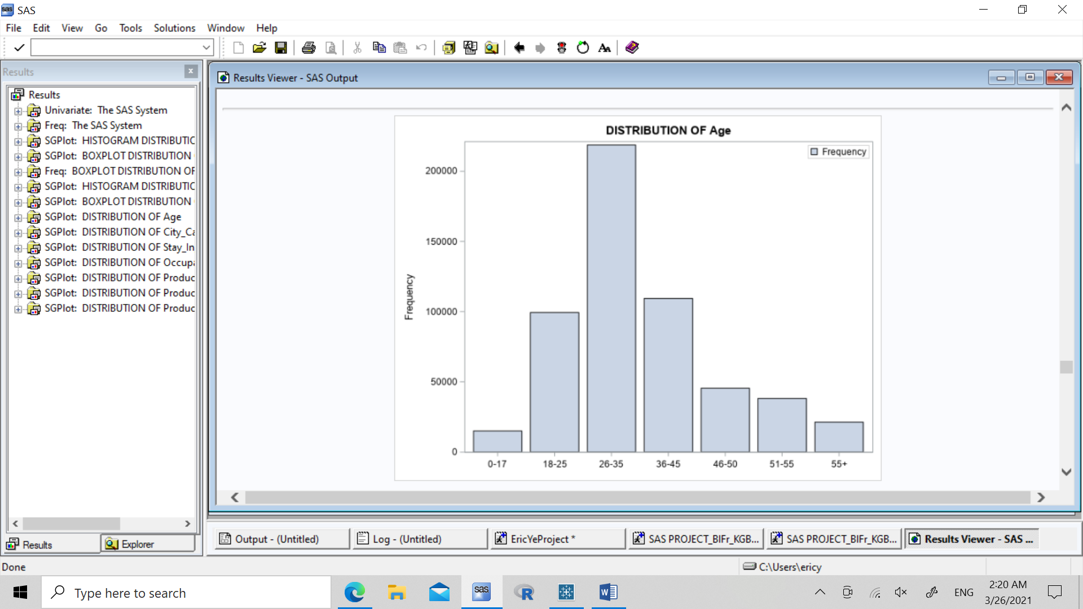 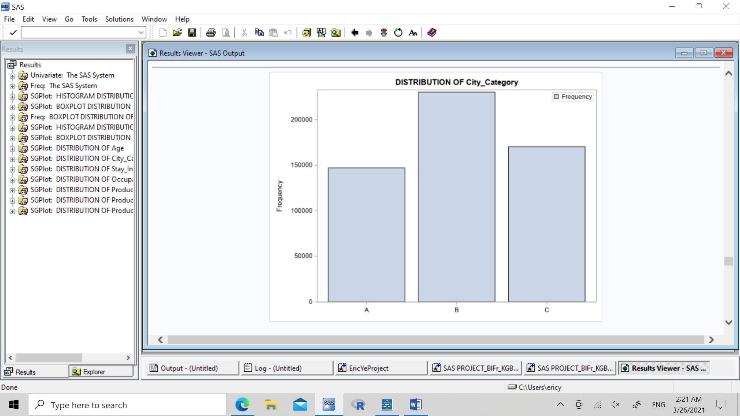

We are shown that Age groups, and City Category have a rather normal distribution

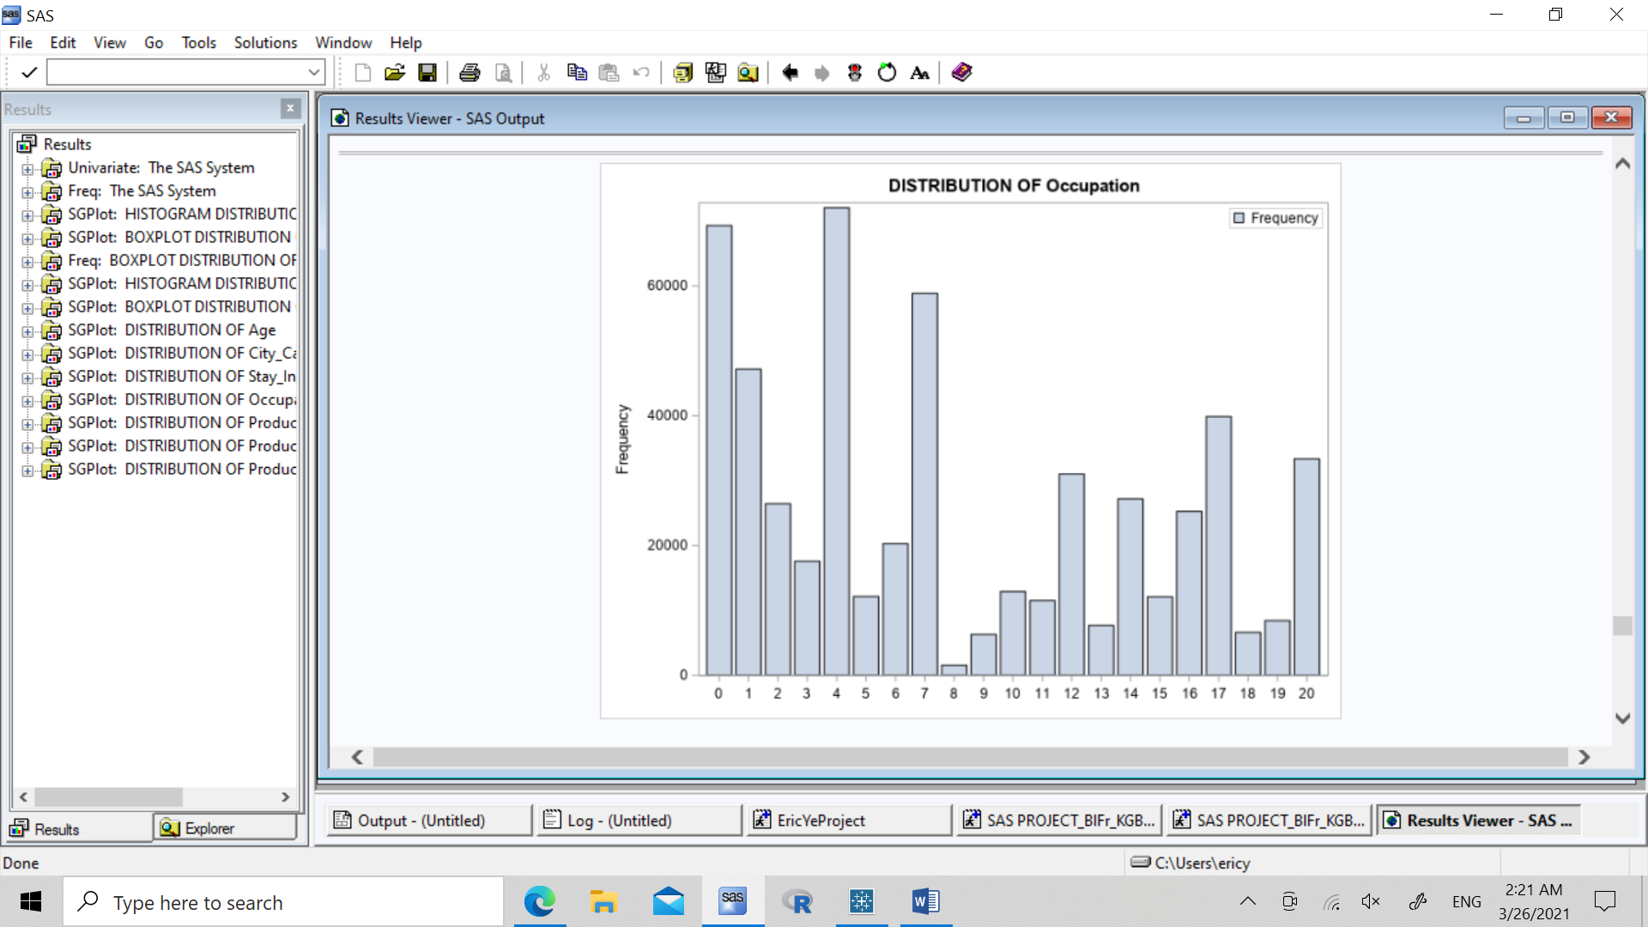

It seems that people with the occupations 0, 1, 4, and 7 produce a large portion of the sales on Black Friday month.

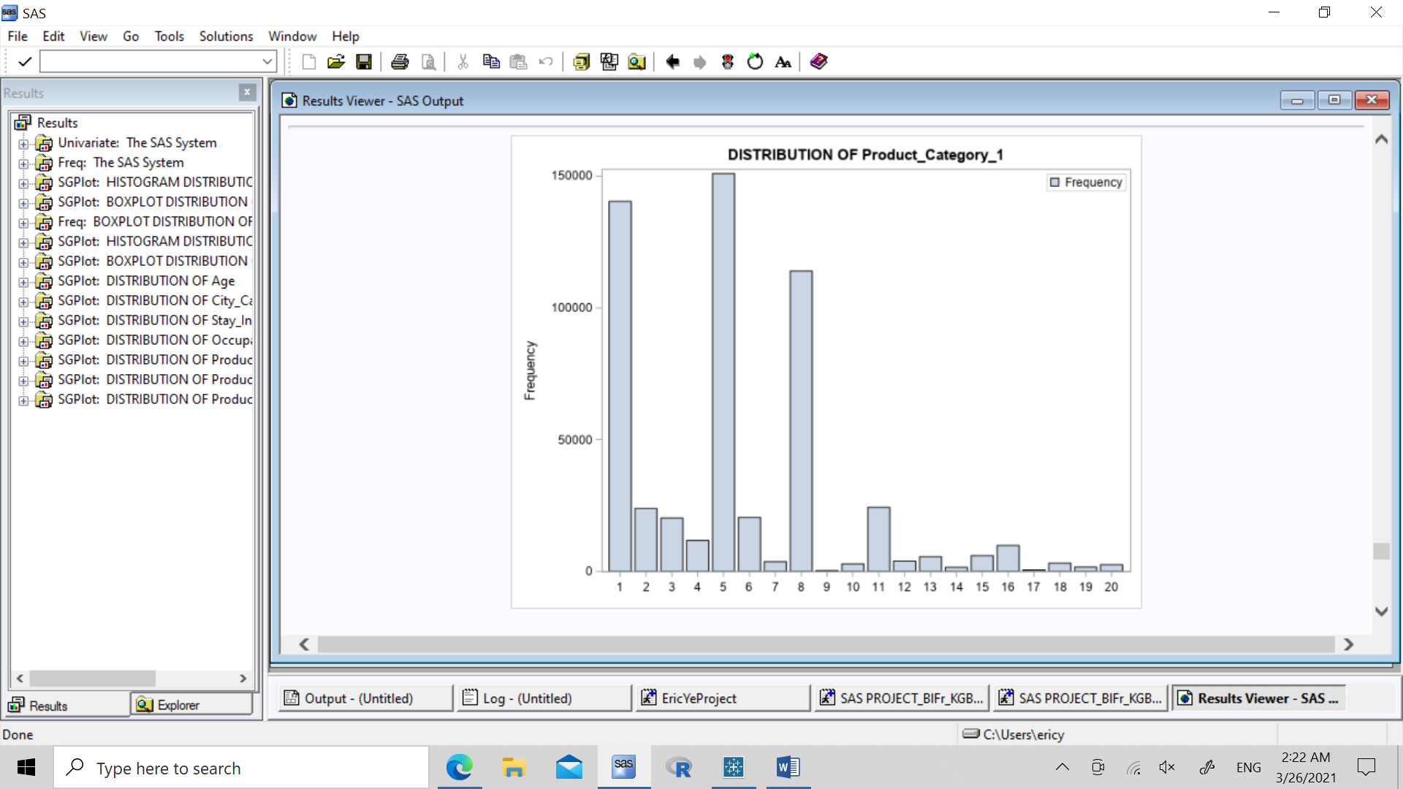

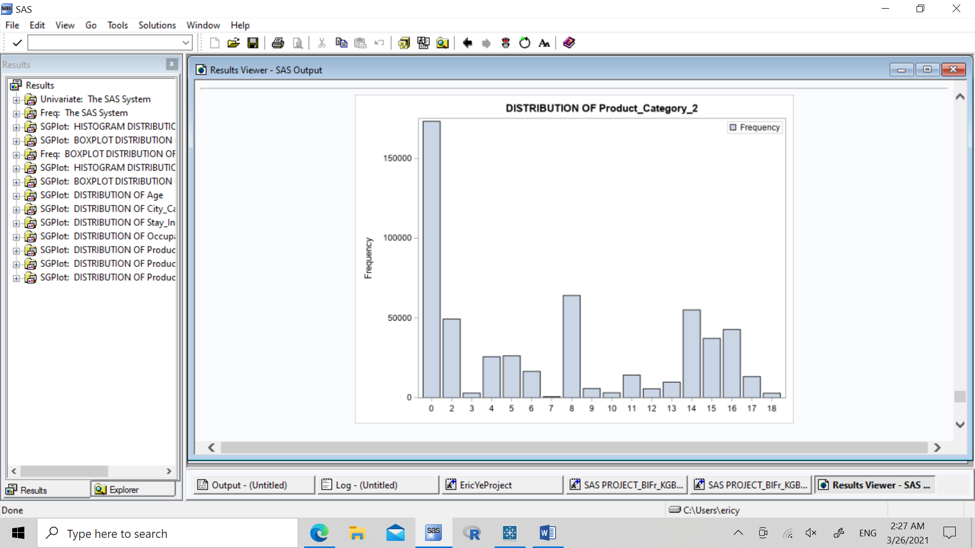 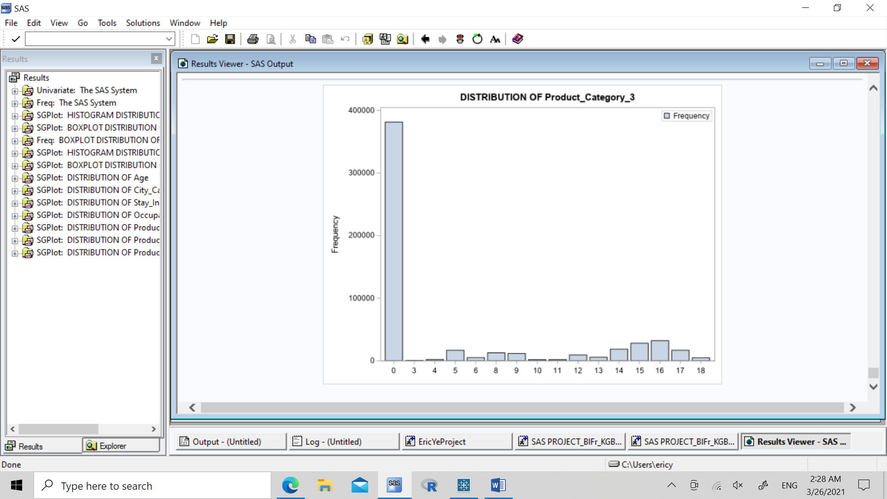

There are not any common patterns throughout the distributions of product categories 1, 2, and 3. However, it seems as if these product categories range from cheapest to most expensive, or perhaps most popular to least popular. In product category 1, items 1, 5, and 8 are extremely popular. However, it seems that many people do not purchase from category 2 and 3 (**Note: 0 means missing items in those categories**). Prediction: Either the items are very expensive, or exclusive and very limited.

**BIVARIATE ANALYSIS:**

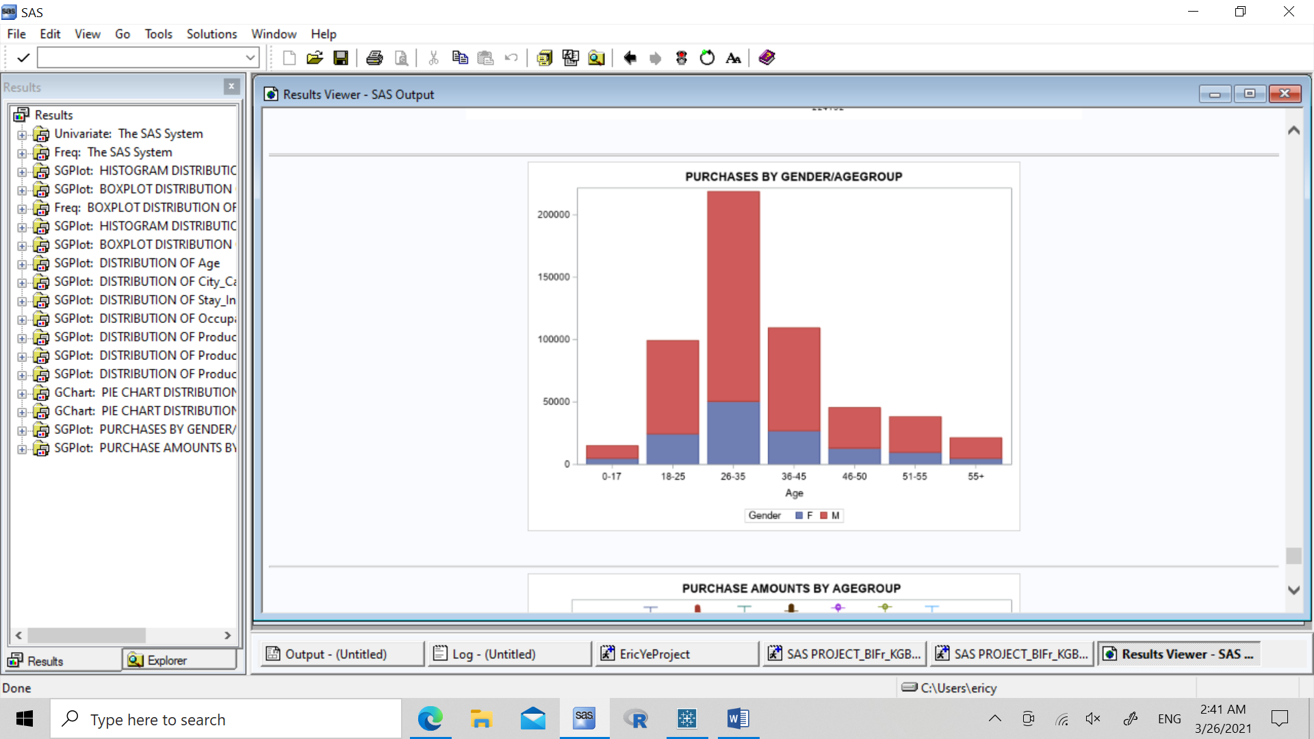

We can see that the majority of shoppers are males, in the age range of 26-35 years of age.

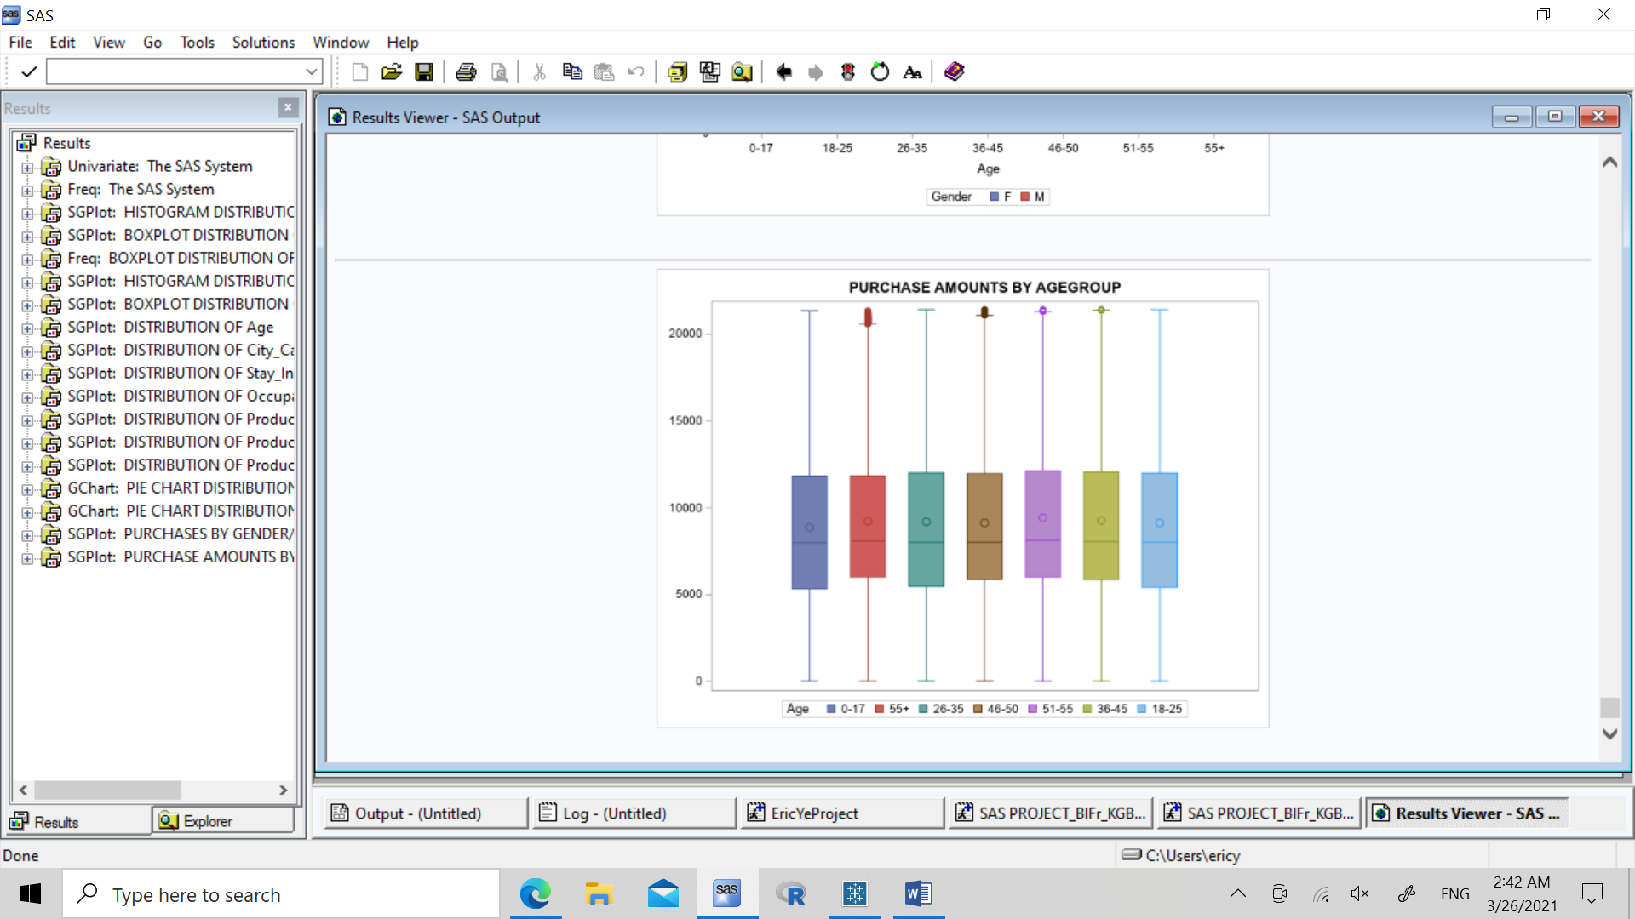

From the distribution of purchase amount in each age group, we are shown that there seems to be not much difference in the purchase amount, no matter what age the customer is. Therefore, there seems to be no correlation between age and purchase amount.

**HYPOTHESIS TESTING:**

H0: No relationship between gender and purchase

**Chisquare test:**

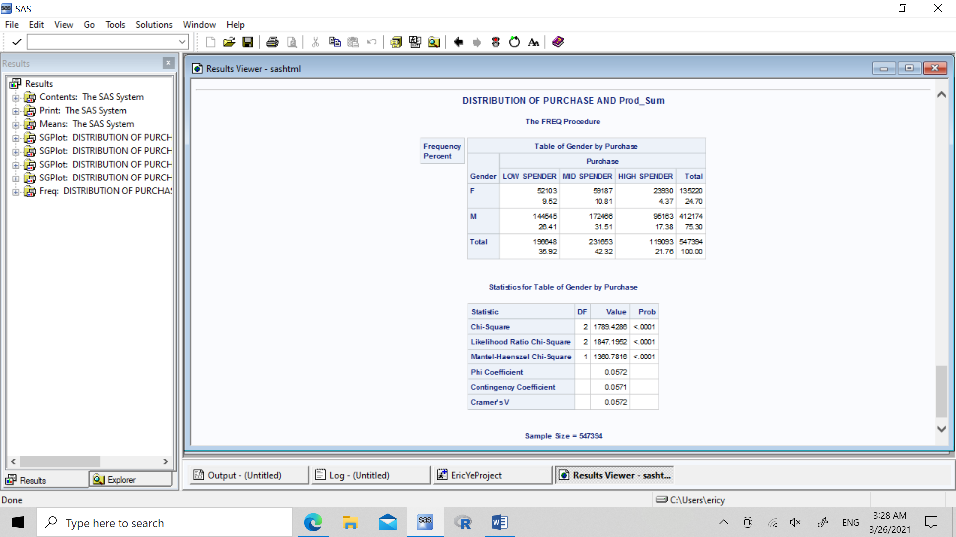

As chisquared p-value is less than 0.05, we can reject null hypothesis and conclude that there is indeed a relationship between gender and purchase.

**Check for Correlations in the masked variables:**

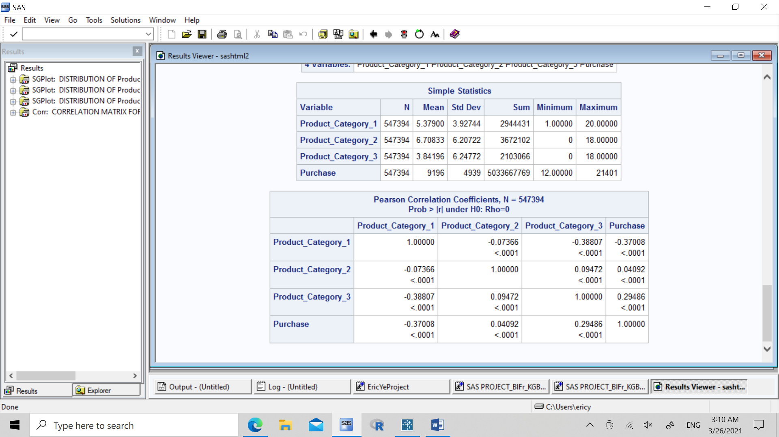

Seems as though there is no correlation between product categories.

**MODELLING:**

**REGRESSION BETWEEN PURCHASE AND MASKED CATEGORICAL VARIABLES:**

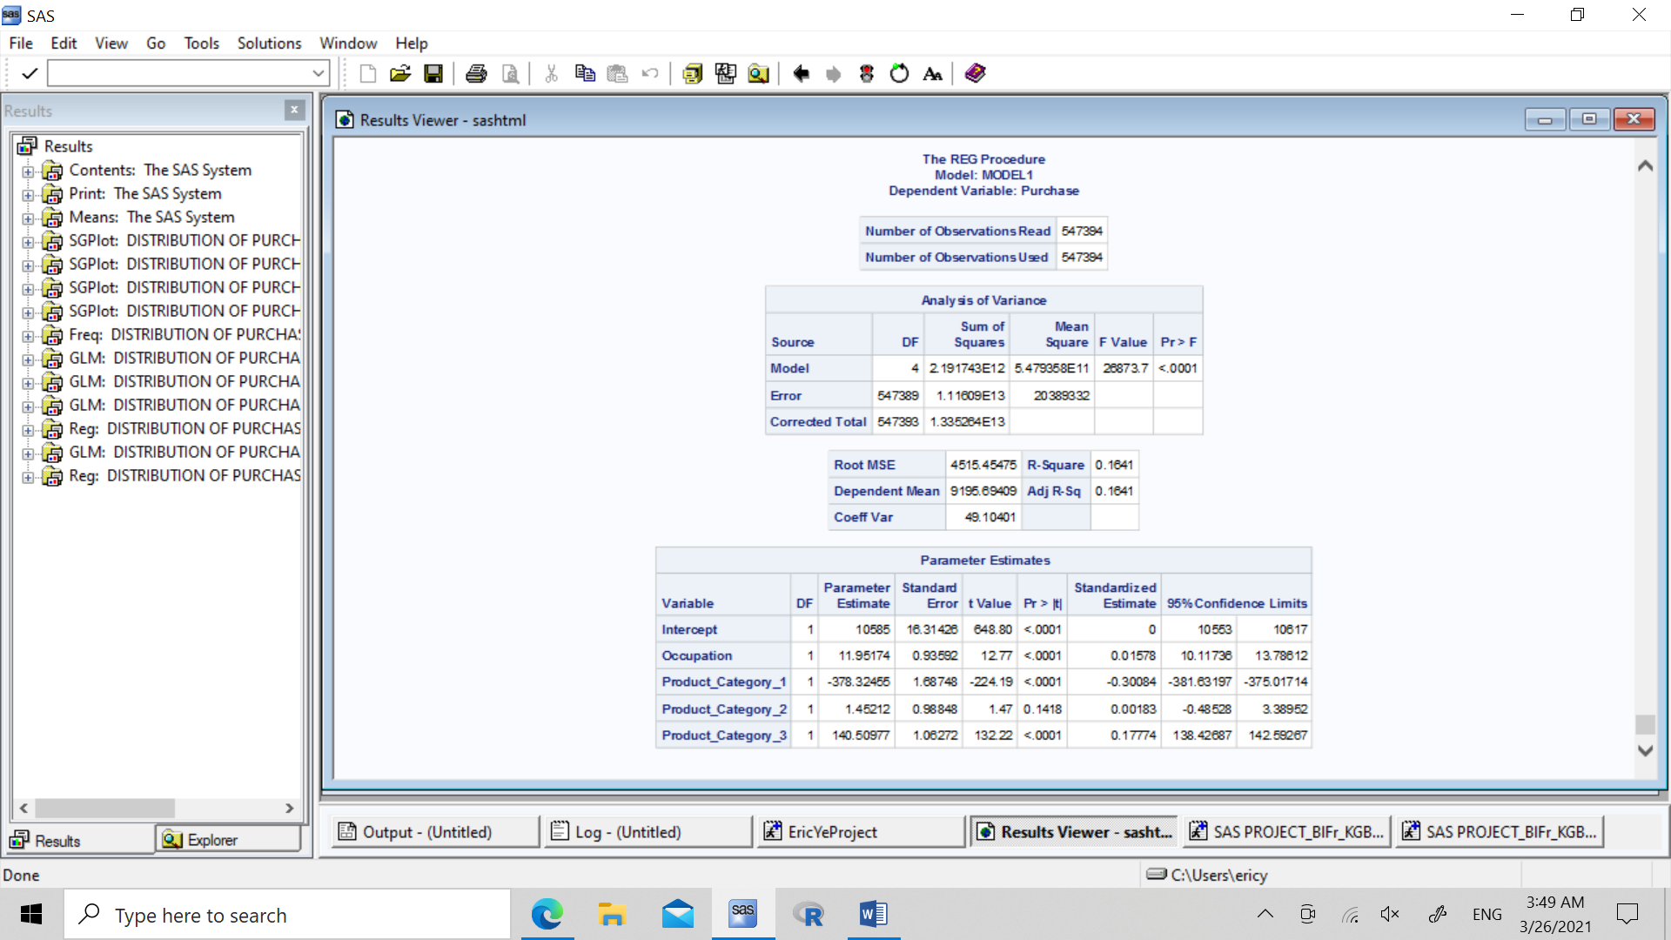

It seems that occupation, product_category_1, and product_category_3, are all significant to the purchase amount, while product_category_3 does not relate to the purchase variable.

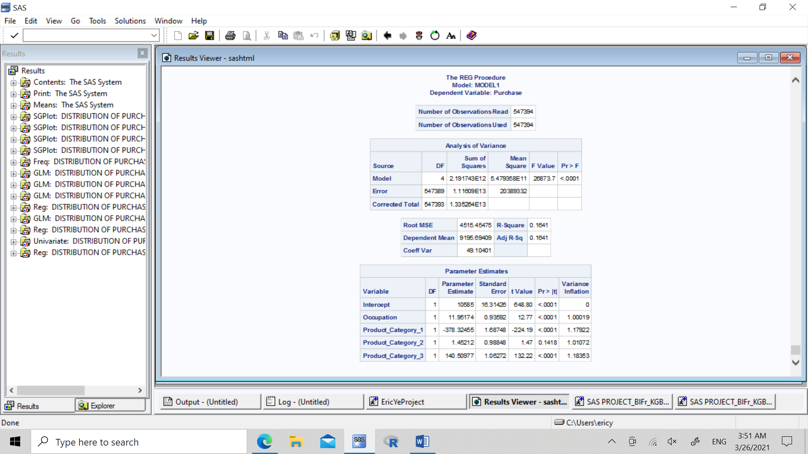

Since variance inflation rates are near 1, then the model is good, since there is not sign of colinearity between the variables.

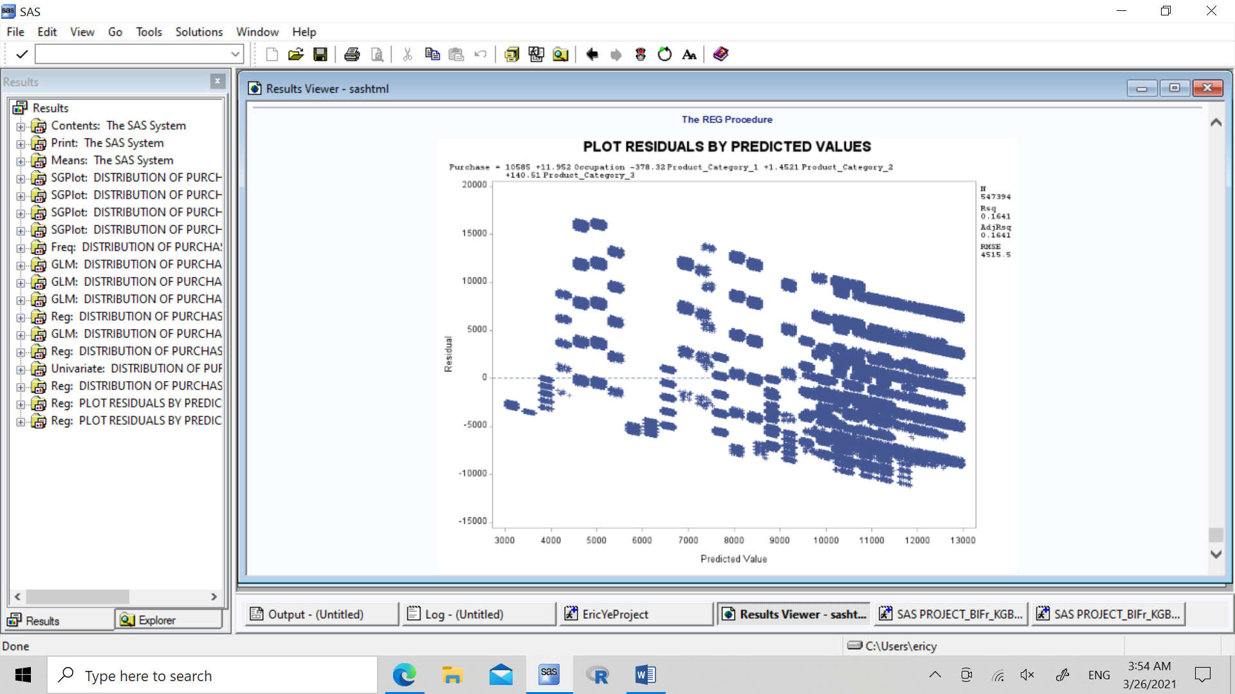

From residuals of the predicted values, we can see that the model is good, since residuals have normality, and seem to have no pattern in the residuals.

**FINDINGS/CONCLUSIONS:**

* Purchase amount can be predicted by the masked variables of product categories and occupation, where product category 1 and 3 are more significant to purchase target variable
* Purchase amount is not correlated with age group
* Purchase amount and number of buyers is correlated with gender variable
* Much higher purchase numbers from males, and especially in the age range 26-35

**RECOMMENDATIONS:**

* To focus on selling more in future Black Friday months, focus on the following variables:
  + Almost 3 times men compared to women shop on Black Friday, reach out to mens products more
  + Especially men in the 26-35 years of age have the most purchase power, try to advertise to this subgroup more
* Focus on selling more products from categories 1 and 3, there is proof of higher purchases
  + In the masked variable product category 1, items 1, 5, and 8 have high success, advertise these items more if possible
* Masked variable occupations 0, 1, 4, 7, have high purchases. If occupations can be known, perhaps put more of these occupation related items on sale or advertised.
* Avoid advertising too many products based on product category 2 or for general age groups, they don’t have significance with purchase amount